May 26th, 2020

Federal Trade Commission

600 Pennsylvania Avenue NW

Washington, DC, 20580

(860) 992-2789

[william.j.violette@gmail.com](mailto:william.j.violette@gmail.com)

To Whom It May Concern,

I did not receive any financial support for this research. This research benefitted from research partnerships with GeoTerraImage, the Center for Affordable Housing and Finance in Africa, as well as Statistics South Africa, which each provided access to data. My employer, the Federal Trade Commission, reviewed the article to ensure that it does not contain any non-public information. The review did not result in any changes to the article. I do not have a position in any organization whose policy positions, goals, or financial interests relate to the article.

Sincerely,

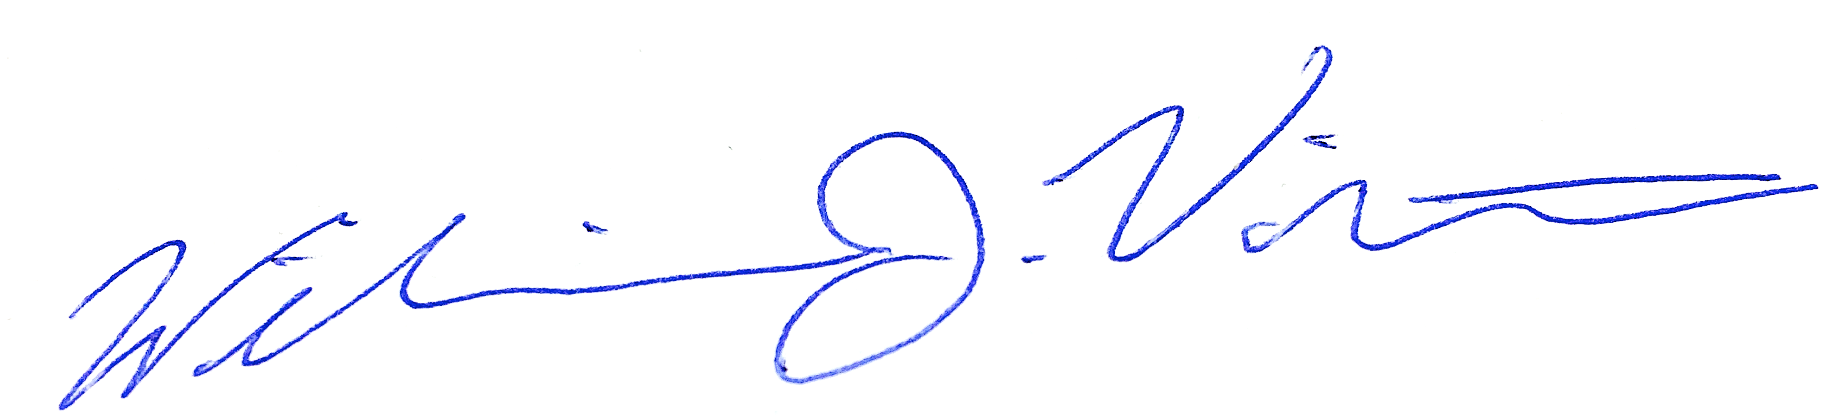

William J. Violette